Mayo University Hospital: LIST OF ITEMS.

We recommend that you pack two separate bags for admission:
X 1 Small bag for the labour ward.
X 1 Bag for maternity ward (postnatal),

Small bag for Labour ward:
- Handheld notes
- All your personnel toiletries
- Old nightdress or t-shirt if you prefer not to wear a hospital gown
- If you wear contact lenses - please bring your glasses.
- First set of baby clothes(vest, Babygro, baby hat) & cellular Blankets
- 1 Disposable nappy
Bag for Maternity Ward:
Mother:
- Night wear or PJs or light clothes
- 1 Dressing Gown / 1 Pair of Slippers
- 2 Bath Towels/ 1 Facecloth
- 2 Packs of Maternity Sanitary Pads
- 6 Regular panties or 2 packs disposable
- Toiletries / Hairbrush / Toothbrush & Paste
- Snacks, water bottle, pen
Baby:
- 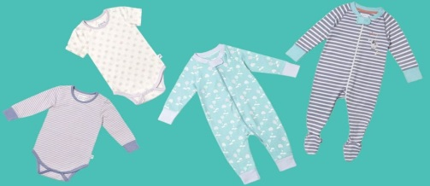 x 4 BABYGRO AND 4 X VEST
- 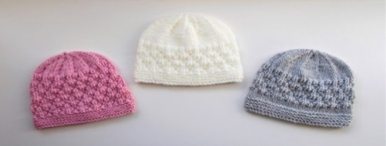 X3 HATS (new Babies lose body heat through their head)
- 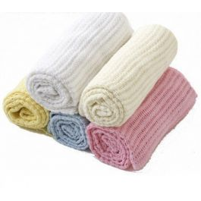x 4-5 Small cellular BlanketsX4 pairs of socks
- 4 Cotton Crib Sheets or Pillowcases (work well)
- 1 Roll of Cotton Pads/ wool / Water Wipes 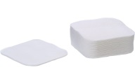
- Approx. 2 Dozen Nappies (New Born)
Please bring any current medication with you and inform the midwife.

