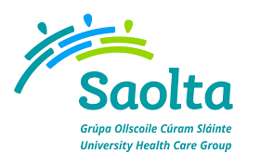
SAOLTA UNIVERSITY HEALTH CARE GROUP, IRELAND
Saolta University Healthcare Group provides a comprehensive range of Medical, Surgical, Paediatrics and Obstetrics and Gynaecology Services to emergency and elective patients on an inpatient, outpatient and day care basis across the West and North West of Ireland.
Galway University Hospitals currently has the following vacancy:
- Senior House Officer Oral & Maxillofacial Surgery
To apply for the above post, please send your CV to medicalrecruitguh@hse.ie
Informal enquires: Mr.Tom Barry, Consultant Oral & Maxillofacial Surgery
Email: tom.barry@hse.ie, Tel: 091 893563
Closing date for receipt of CV’s is Friday 25th January 2019 at 4pm
