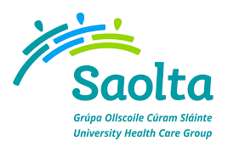
SAOLTA UNIVERSITY HEALTH CARE GROUP, IRELAND
Saolta University Healthcare Group provides a comprehensive range of Medical, Surgical, Paediatrics and Obstetrics and Gynaecology Services to emergency and elective patients on an inpatient, outpatient and day care basis across the West and North West of Ireland.
Portiuncula University Hospital currently has the following vacancies:
- Medical Registrar – Respiratory, AMU, Geriatrics & General Medicine
- Paediatric Registrar
- Obstetrics & Gynaecology Senior House Officer
- Medical Senior House Officer
- Anaesthesia Senior House Officer
To apply for the above post, please send your CV to medicalrecruitpuh@hse.ie
Informal enquires: Mr. Brian Mullin and Ciara Brady, Portiuncula University Hospitals
Email: ciara.brady2@hse.ie or medicalrecruitpuh@hse.ie Phone: 09096 48303
Closing date for receipt of CV’s is Friday 31st May 2019
