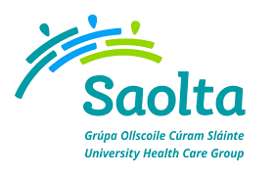
SAOLTA UNIVERSITY HEALTH CARE GROUP, IRELAND
Saolta University Healthcare Group provides a comprehensive range of Medical, Surgical, Paediatrics and Obstetrics and Gynaecology Services to emergency and elective patients on an inpatient, outpatient and day care basis across the West and North West of Ireland.
Portiuncula University Hospital currently has the following vacancy for July 2020:
- Obstetrics & Gynaecology Registrar

To apply for the above post, please send your CV to medicalrecruitpuh@hse.ie
Informal enquiries: to Ciara Brady Medical Recruitment Portiuncula Hospital. Email: ciara.brady2@hse.ie, Tel: 090 9624611

Closing date for receipt of CV’s is Friday 14th August 2020 at 4pm
