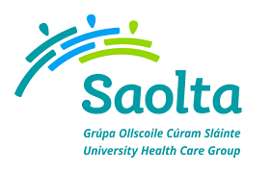
SAOLTA UNIVERSITY HEALTH CARE GROUP, IRELAND
Saolta University Healthcare Group provides a comprehensive range of Medical, Surgical, Paediatrics and Obstetrics and Gynaecology Services to emergency and elective patients on an inpatient, outpatient and day care basis across the West and North West of Ireland.
All Hospitals in the Group play a leadership role in the Acute Service Delivery, serving a catchment area of 1 million people. All Hospitals in the Saolta University Healthcare Group are affiliated to the National University of Ireland at Galway and are involved in the undergraduate and postgraduate training of medical and other healthcare professionals.
Sligo University Hospital is a busy hospital with a compliment of 323 beds and provides a wide range of general and regional services in the North West Region.
Sligo University Hospital is an integral part of Saolta Group since August 2013 and has the following locum consultant vacancies.

Locum Consultant Haematologist
Period of 6 months commencing in November 2017
Temporary Consultant Dermatologist
Period of 12 months commencing as soon as possible
Temporary Consultant Microbiologist
Period of 12 months commencing in December 2017

To apply for the above post, please send your CV to Jan Scott, HR Department, Sligo University Hospital, The Mall, Sligo. Email: Jan.scott@hse.ie

Informal enquiries to: Martha Saba, Medical Manpower Manager, Sligo University Hospital, Saolta University Health Care Group on 071 91 71111/ 087 969 8254
