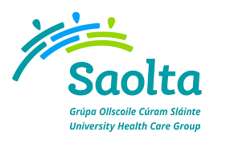
SAOLTA UNIVERSITY HEALTH CARE GROUP, IRELAND
Saolta University Healthcare Group provides a comprehensive range of Medical, Surgical, Paediatrics and Obstetrics and Gynaecology Services to emergency and elective patients on an inpatient, outpatient and day care basis across the West and North West of Ireland.
All Hospitals in the Group play a leadership role in the Acute Service Delivery, serving a catchment area of 1 million people. All Hospitals in the Saolta University Healthcare Group are affiliated to the National University of Ireland at Galway and are involved in the undergraduate and postgraduate training of medical and other healthcare professionals.

Galway University Hospital currently has the following vacancy:
- Registrar Ophthalmology, Start date 8th January 18
To apply for the above post, please send your CV to medicalrecruitguh@hse.ie
Informal enquiries: to Mr. Brian Mullin, Medical Manpower Manager, Saolta University Health Care Group, Galway University Hospitals 091-892122

