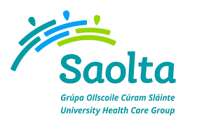
SAOLTA UNIVERSITY HEALTH CARE GROUP
Saolta University Healthcare Group provides a comprehensive range of Medical, Surgical, Paediatrics and Obstetrics and Gynaecology Services to emergency and elective patients on an inpatient, outpatient and day care basis across the West and North West of Ireland.
Consultant in Anaesthetist (Full-Time Temporary Contract)
Roscommon University Hospital & Portiuncula University Hospital

This is an appointment to the Saolta Hospitals Group on a Type B basis under the Consultants’ Contract 2008 (as per standard text issued by the HSE) by the Health Service Executive. The initial commitment for this post will be to Roscommon University Hospital for 39 hours per week, and on call commitment to Portiuncula University Hospital. This post may be subject to restructuring in the future to facilitate the reorganisation of acute services in line with new clinical models of acute and community services. It is noted that the post must be congruent with the requirements of, and facilitate implementation of, the HSE’s National Clinical Programmes including commitment to deliver the relevant performance outcomes.
Informal enquires to: Dr. Aine Ni Chonchubhair Associate Clinical Director Perioperative, Portiuncula University Hospital.

Email: Aine.NiChonchubhair@hse.ie Phone: 090-9648541

To apply for the above post, please forward your CV to medicalrecruitruh@hse.ie

Closing date for receipt of applications is Tuesday 27th November 2018 at 4.00pm

